**How to access the “Maximum Framework Rates” for Project Management & Full Design Team Services RM3741**

Access the eSourcing tool via: <https://gpsesourcing.cabinetoffice.gov.uk/sso/jsp/login.jsp>

Customer support call 0345 410 2222

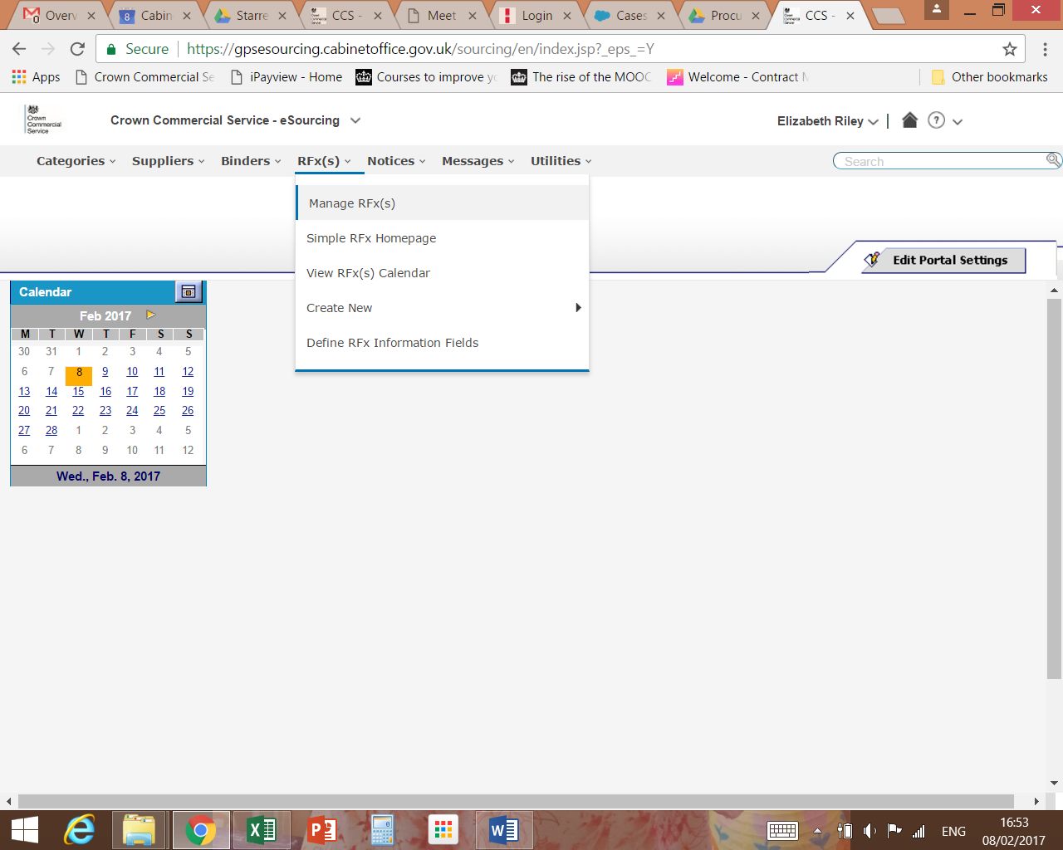

Hover over RFx(s), click on Manage RFx(s) in the dropdown.

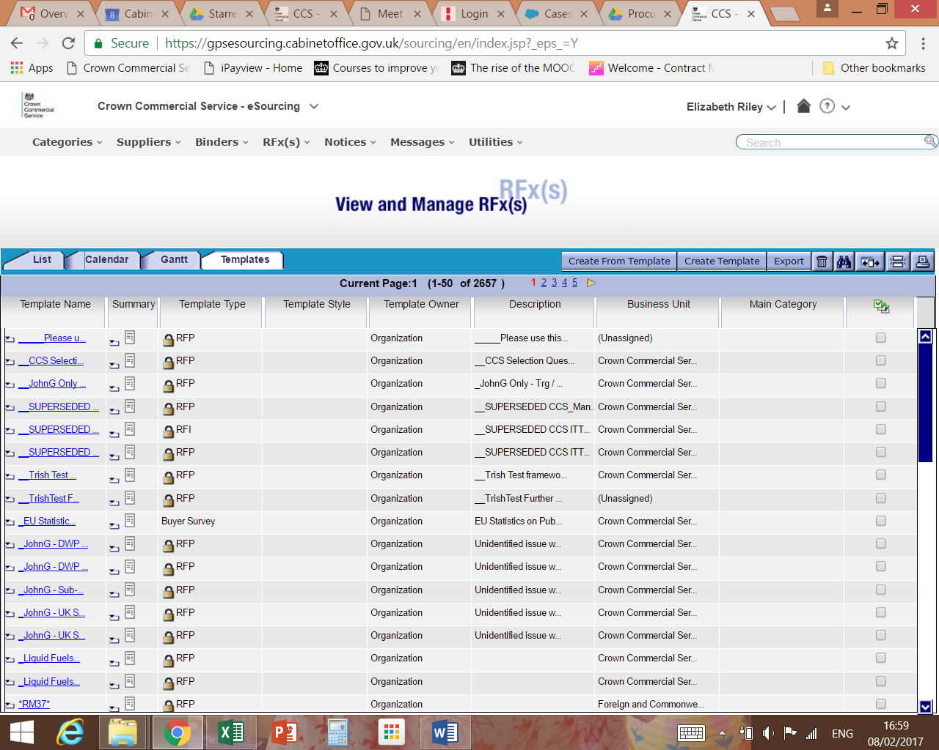

Click on “Templates” tab

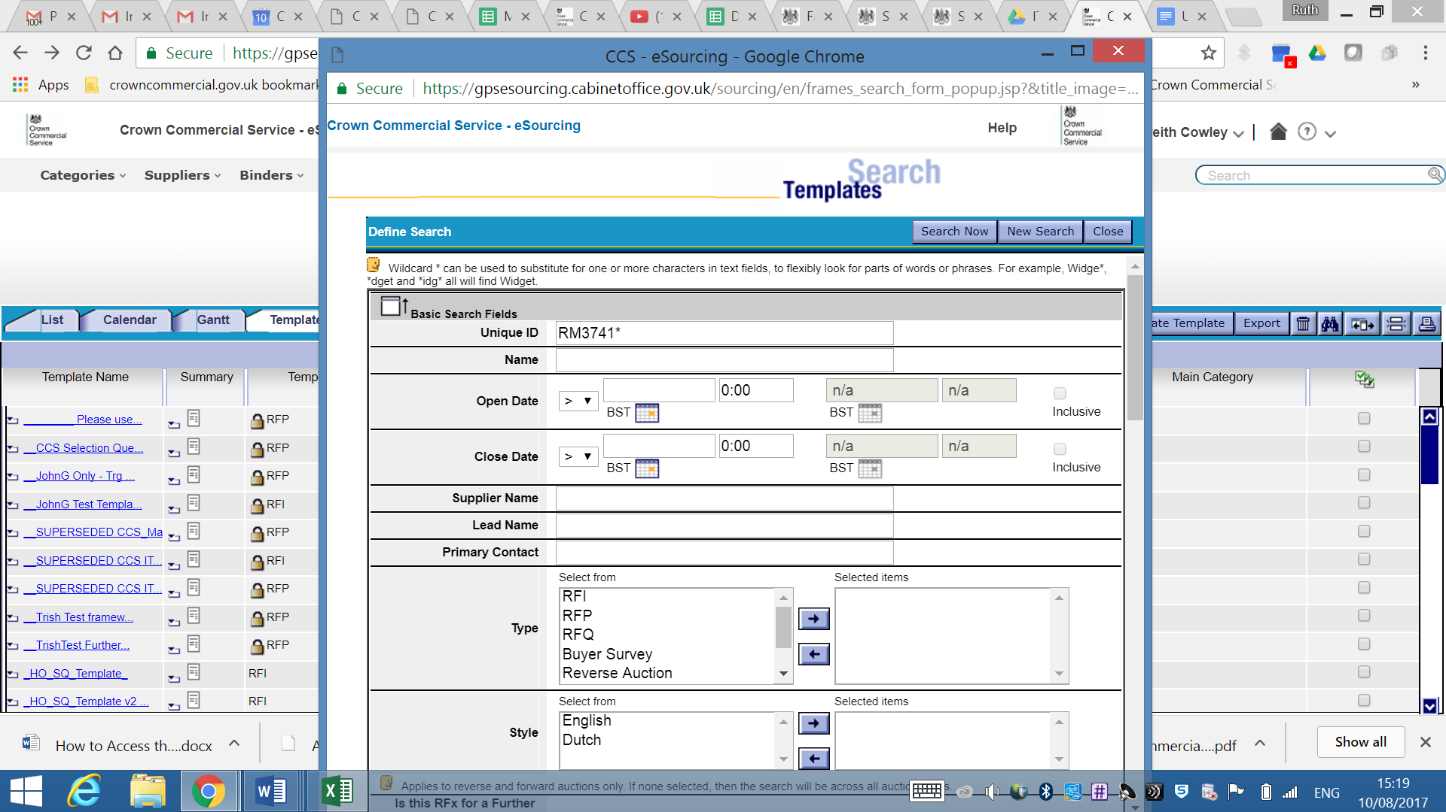

Click on the binoculars to open the search box.

Type *RM3741* into the “Name” box and click the “Search Now” tab.

Ensure you type the after the RM3741.

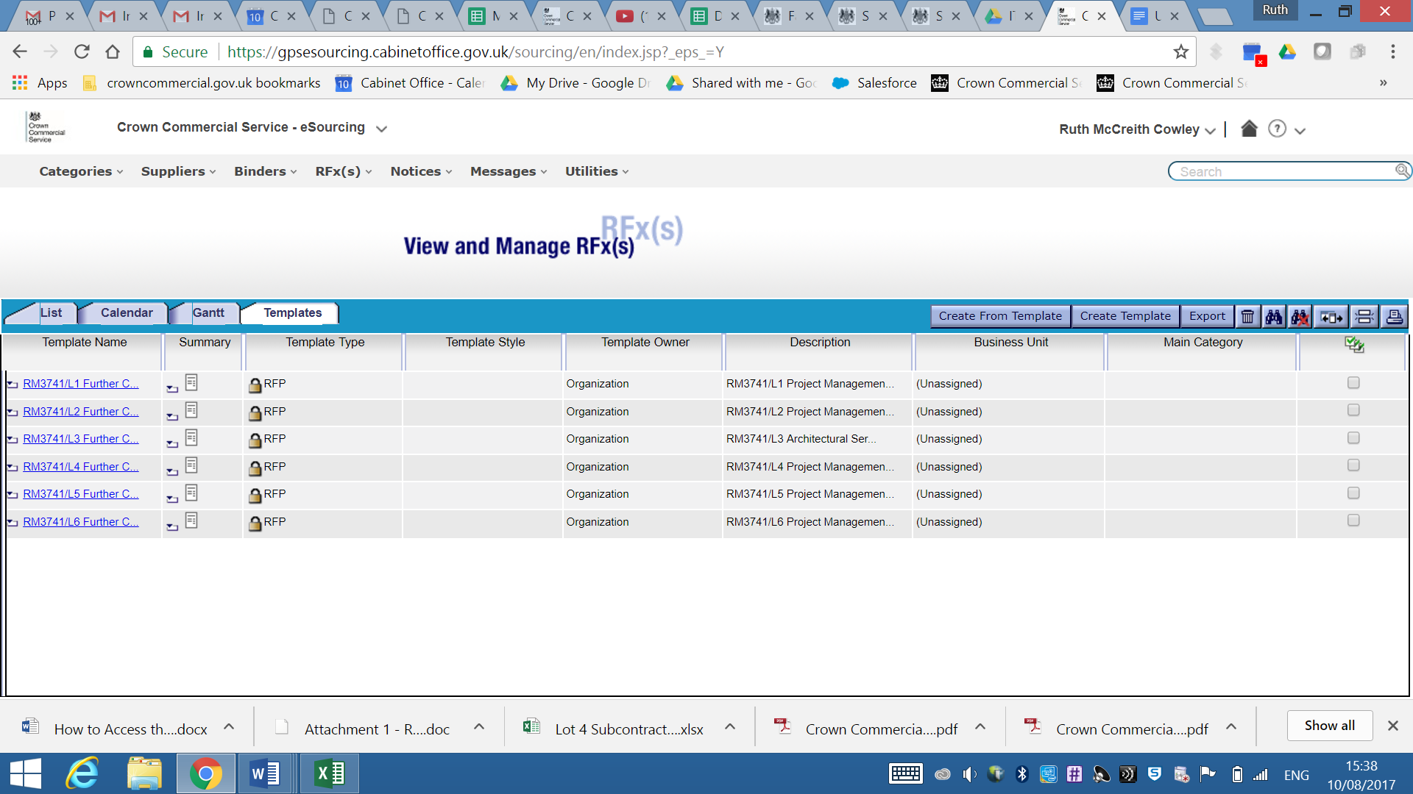

This screen will now open.

Click on Lot 1 Multi-Disciplinary Services

Lot 2 Project Management Services

Lot 3 Architectural Service

Lot 4 Cost Management Services

Lot 5 Civil & Structural Engineering

Lot 6 Building Services Engineer

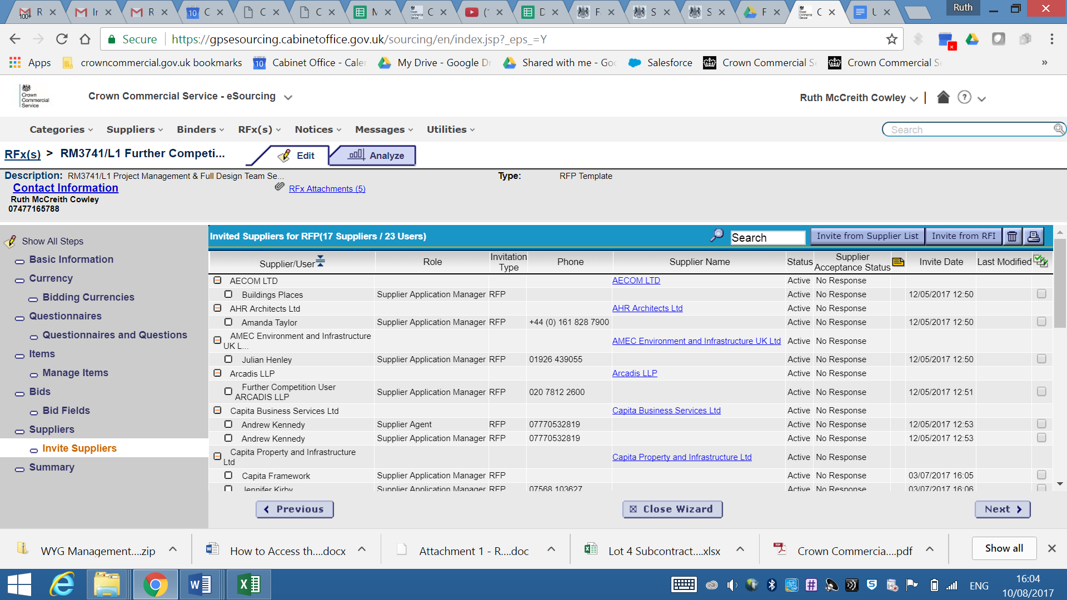

This example shows Lot 1.

At the top of the screen click on RFx Attachments

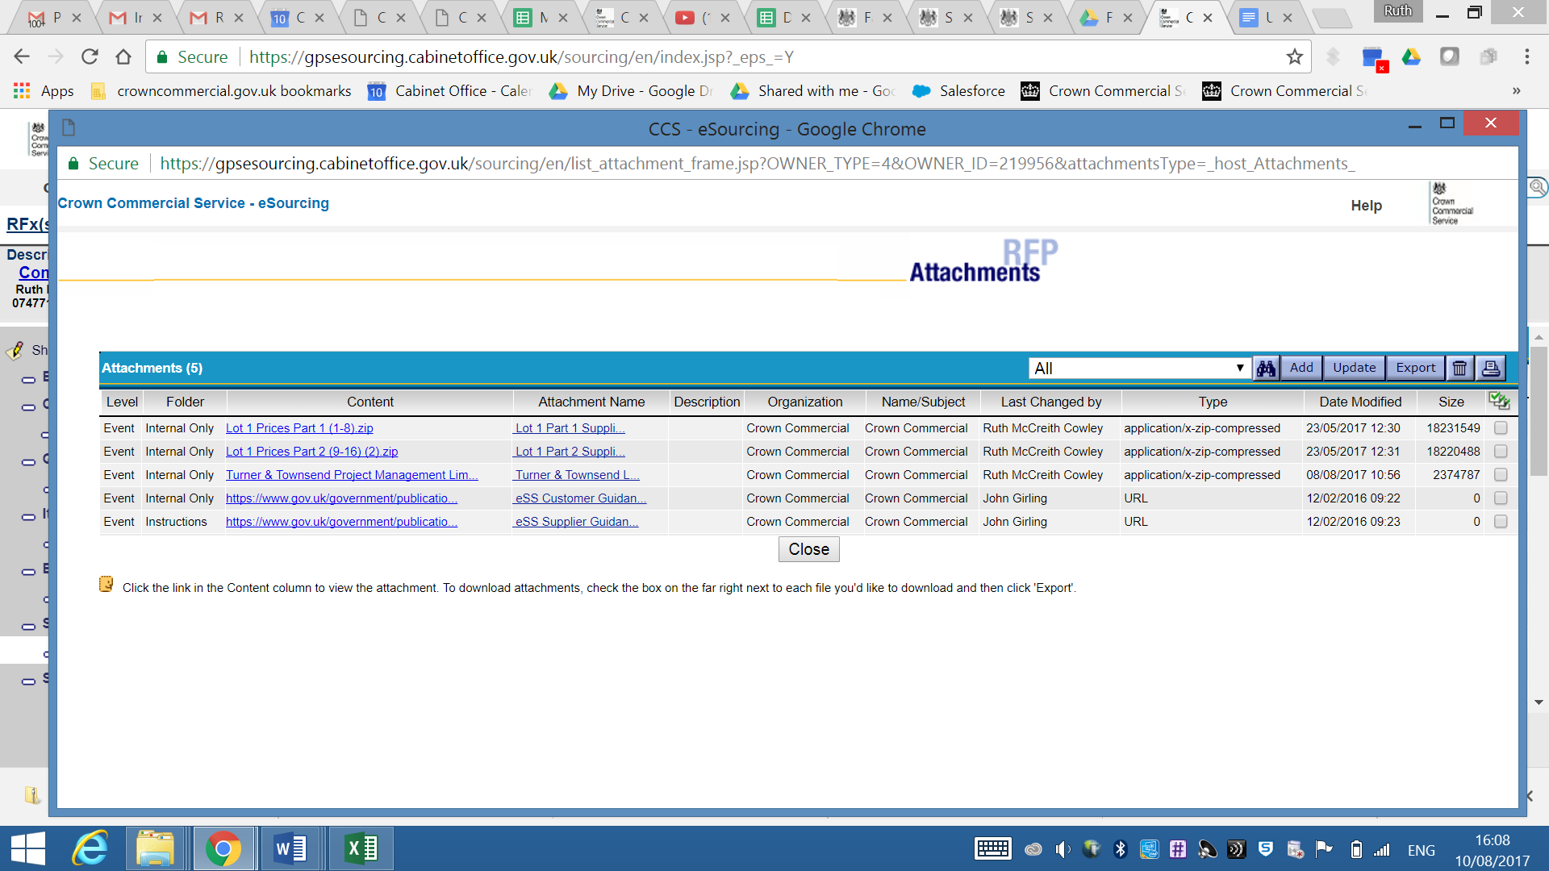

The drop down shows the available attachment.

Click on “Lot 1 Maximum Framework Rates Zip”

(Please note Lot 1 Prices are split into 2 files – due to their size)

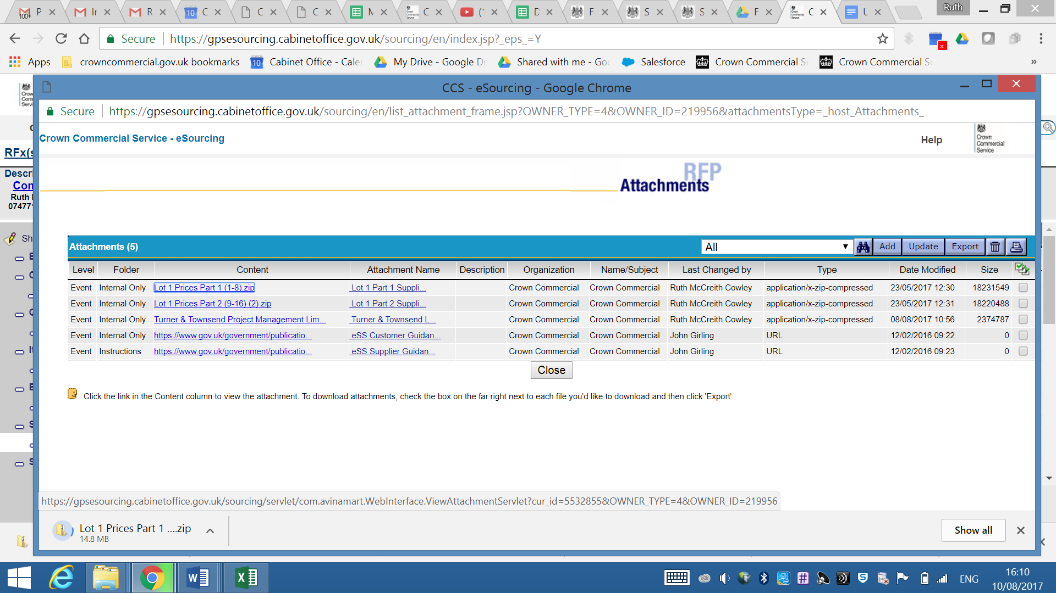

Click on the Zipped Folder to access the Maximum Framework Rates.

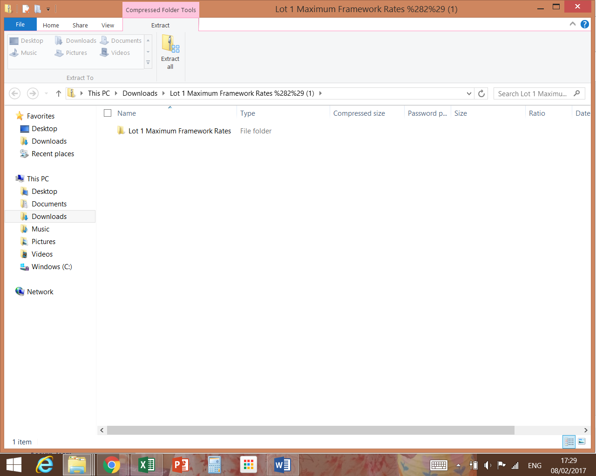

You will see the Lot 1 Maximum Framework Rates folder.

This folder contains the maximum framework rates for all suppliers within the Lot.