

**1. What is the difference between the lots?**

**RM3785 Public Sector Managed Print and Digital Solutions**

**Frequently Asked Questions (FAQs)**

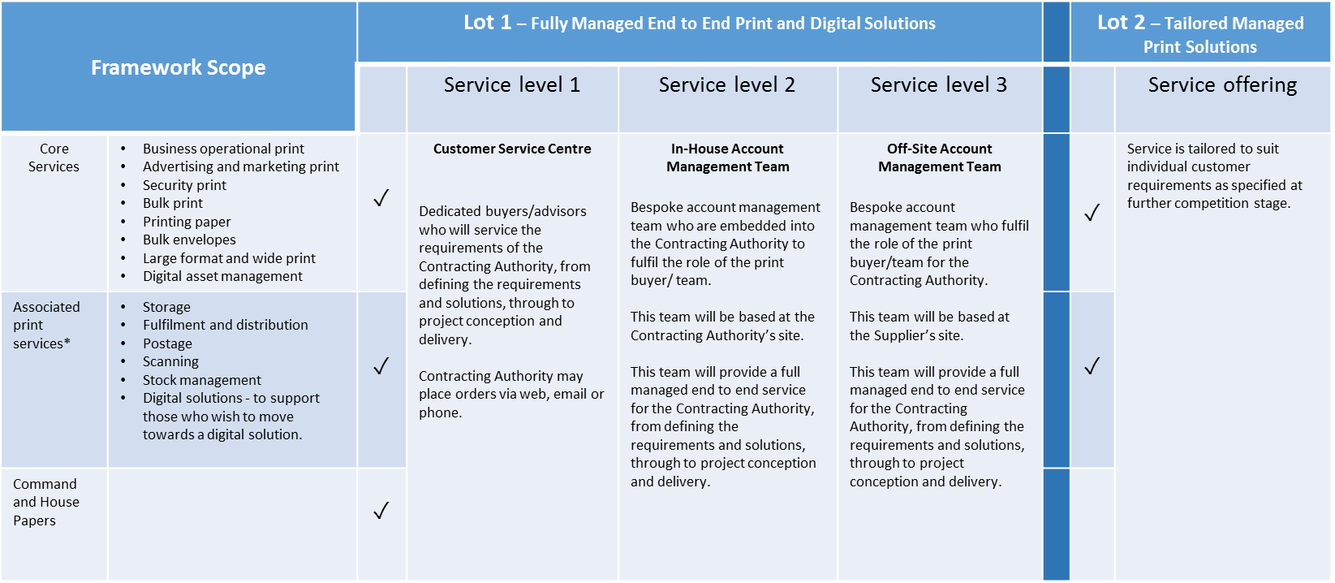

*These services are only available as part of a core print requirement.

Customers need to decide which lot best suits their requirements and their level of service.

**Framework Access**

**2. Access options**

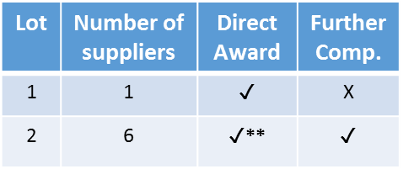

**\*\* NB. Lot 2 Direct Award is only suitable for the printed items listed in the lot 2 rate card**

**3. Can I make a Direct Award via Lot 2?**

If customers are able to determine which supplier provides best value for money for their requirements, it is possible to make a direct award via lot 2.

As there is no printed product rate card and the lot 2 management fee is not set a further competition will be required for the majority of customers (to enable them to compare supplier bids and select best value for money)

**Direct Award – Further Information**

* Direct award may be suitable for low value, ad hoc requirements.
* It is not a route for bypassing competition.
* It eliminates the option for any further reductions in price.
* The price quoted on the rate cards are the prices you will pay.

**4. What shall I include in my Statement of Requirements/Specification?**

See the “tips for creating you specification” document on the CCS website for further guidance about the information you may wish to include when developing your Statement of Requirements/Specification.

**5. How long shall I allow for running a further competition?**

This will depend on the complexity of your requirement. Allow enough time for the supplier to be able to return all of the information requested.

**6. How do I conduct a further competition?**

The Framework Guidance Document, available on our website, offers guidance on how further competition works and important factors to consider.

**7. What are framework agreements and call-off contracts?**

Our Frameworks/Agreements

Suppliers

Customer A

Framework

Call-Off

Customer B

Customer C

**8. How long can a call-off contract be?**

You may let a call-off contract for a maximum of 4 years (the RM3785 framework has been let for a term of 2 +1 +1 years).

**9. Can the call-off contract terms be amended?**

The RM3785 Managed Print and Digital Solutions framework provides a [call off order form and a standard set of call off terms](../Attachment%204b%20Call%20Off%20Contract%20(Framework%20Schedule%204)%20V1.0.doc). Once populated these will comprise the call-off contract that you will sign with your supplier.

The call off order form - which is set out as a template, is ready to be populated with customer specific requirements. There is flexibility to supplement or refine the call off terms with special or additional terms.

Special terms provide scope for further tailoring where the call off contract does not provide contractual cover for your requirements. Under EU procurement rules, special terms must be used sparingly as a mechanism for supplementing or refining aspects of a call-off contract. They must not seek to redefine the underlying commercial parameters of the contractual relationship. You should always seek professional advice before considering the use of these terms.

***Questions 10-12 are only applicable to current PVP customers.***

**Transition / Implementation**

**10. What are the timescales for transition?**

The current PVP contract will expire on 30th June 2017 and from the date the new framework is awarded (December 2016) until the PVP expiry date work will gradually transition from PVP to the new framework (over a 6 month period).

**11. How do I transition from the PVP Contract to the new framework?**

In consultation with customers, a transition plan detailing key milestones will be drawn up between the incumbent supplier and the new supplier.

**12. What do I need to do to prepare for transition from the PVP contract to the new framework agreement?**

* Obtain key pieces of information from incumbent suppliers. This may include: a specification, buying profile, pricing data, security information, IT information and management information.
* Prepare the call-off contract.

**13. As a current PVP customer, will I automatically transition?**

Current PVP customers will not automatically transition. Customers will work in collaboration with the incumbent and new supplier to agree transition activities.

**14. How do I access the new framework if I am not currently a PVP customer?**

1. Decide which lot best meets your requirements.
2. If lot 1, engage with the supplier to discuss on-boarding.
3. If lot 2, carry out further competition to select supplier.