Technology Expense Management
Framework reference: RM3802
Start date: 10/07/2018
End date: 09/07/2021
OJEU contract notice: ttps://ted.europa.eu/udl?uri=TED:NOTICE:353674-2018:TEXT:EN:HTML&src=0

What you can buy through this framework
This agreement gives you access to a service which analyses technology spend data and identifies areas of potential waste. In addition to identifying these savings, the service will enable you to view an holistic view of your estates, rationalising costs and creating and maintaining an accurate inventory.

The Calero Veropath Technology Expense Management (TEM) solution analyses a range of information about your telecoms or technology usage and spend and provides reports highlighting areas where you can save money, avoid costs and better plan for buying services in future. It does this by combining your organisation’s billing and usage data, with contractual and organisational data to create a detailed inventory. This is kept accurate by regular updates. TEM services can:

- Identify historic errors;
- Find opportunities for short and medium term benefits; and
- Inform future technology strategies to match services to demand.

The TEM process is cyclical and a standard process is illustrated below.
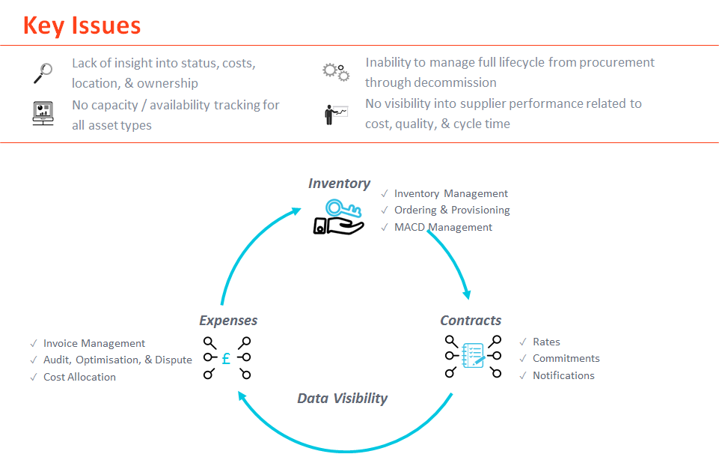
Who can use this framework?

This framework is available for use by central government, devolved administrations, wider public sector and third sector organisations including, but not limited to, local government, health, education, police, fire and rescue, housing associations and charities. Contact us if you are not sure about whether your organisation can use the framework.

Benefits of using the framework

The supplier has been awarded the framework following a robust and compliant tender process. The prices achieved for the services are competitive and will be reviewed annually to ensure they offer value-for-money.

CCS has set high performance and security standards for the service and will manage these at framework level. This will simplify the call-off procedure for customers, as these aspects have already been evaluated and assured.

Benefits of using TEM services

TEM is widely used by private sector organisations and has been found to save companies in the region of 20% of their annual telecom spend in the first year of use, plus subsequent year savings. CCS has provided a managed service for TEM and we also found that savings of 20% can be achieved.

This has been achieved through:
- Providing evidence of waste and mismanagement of technology estates;
- Identifying services which are being provided and paid for but are unused e.g. fixed lines in vacated buildings (known as zero use);
- Identifying services that companies have continued to pay for, which were assigned to staff who have left, and have not been recovered;
- Identifying old contracts which are charging at a higher rate; and
- Identifying services which could be cheaper on alternative tariffs.

How the framework is structured
The supplier offers seven services. Services 2, 3 and 4 are only available if you utilise the core TEM service because they would not be appropriate as standalone services. These services are additional services which provide a value-add to the main service.

- Service 1: Technology Expense Management (TEM);

This provides regular analysis and reporting of your spend on telecoms and technology services, tariffs and usage. The service will create an accurate inventory of your telecoms and technology estate. Through having accurate and up to date information at your fingertips, it will help to track spend and identify ways to drive efficiencies, leverage savings, develop better buying strategies through providing reports plus optimisation and benchmarking.

The service is provided via a secure digital platform accessed through an online portal, called the Calero Veropath Portal.

Savings can be achieved through historical rebates and future savings:

- Future savings (as per Calero’s guidance) means savings which will be achieved for a maximum period of twelve (12) months immediately after the completion date of implementation of the savings identified;
- Historical rebates means savings which will be achieved from a maximum period of seventy two (72) months prior to the date when billing errors are presented to the network provider.
The next three services can be used in tandem with Service 1.
- Service 2: Contact Services:
This service assists with verifying and correcting customer records and includes contacting individual users to confirm the accuracy of your records. This is carried out to support the achievement of savings.
End users will be contacted via email, SMS and/or telephone to confirm the status of their mobile device(s). Any inaccuracies which have been identified will be corrected in your inventory, to improve the quality of the data, identify surplus devices and align device ownership to technology policies and employees.
Calero will work with customers to implement their processes across the customer’s organisation in order to maintain an up-to-date and accurate end user inventory. This will include a monthly HR extract which captures any leavers and movers. Additionally, customers will have access to the Calero Veropath Portal (Service 1) to make ad hoc changes, which will enable customers to ensure that the Portal holds the definitive record.
This type of exercise is usually conducted over a three-month period as this time frame allows for an appropriate amount of time to pass between each end user communication, data collations and data correction. Calero has a customer service team who perform these activities for you and is an administrative support function.
- Service 3: Personal Cost Management:
This service is provided through a comprehensive personal cost management (PCM) module within the Portal (Service 1) and a supporting mobile app which is available for both Apple and Android users.
The solution is provider agnostic and can present mobile data from across multiple suppliers to give end users a centralised view of their accounts. This solution can be expanded to include adjacent technologies to mobiles. End users will receive a monthly electronic notification that their bill is available to view online. The wording of this notification can be customised.
Calero have found that 10 - 15% of monthly mobile expenditure is allocated as personal. It is common to see an immediate reduction of approximately 10% in personal usage through the deployment of PCM alone. A benefit of PCM is that a quarter of your users will have 100% of their usage automatically allocated once your corporate address book (from HR and IT inventories) has been set up in the Portal.
The Calero PCM solution is based on an automated workflow process which is activated once the defined data sets have been loaded, validated and published to the Portal. The only tasks which need to be maintained on a monthly basis are:
- Corporate address book - customers can add or remove numbers from the address book at any point to support the automation of calls being allocated to business;
- Leavers/Joiners - once mobile devices are allocated to a new end user, a new PCM login will be required for them. If a user leaves the organisation, their account will need to be closed.

- Service 4: Tactical Provisioning/Ordering:

This service allows the supplier to facilitate the placing and completion of orders for services or equipment from existing contracts. This service will create an accurate recording on an inventory and online portal.

Once an order has been submitted by a customer end user, Calero will perform checks to ensure the form has been completed correctly, that appropriate approval has been given and there are no zero usage devices within the customer’s estate, which could be re-deployed to meet the order requirements.

Once these checks have been performed, Calero will place the order with the agreed telecoms provider and all orders will be tracked until completion. All these details will be captured within the TEM portal.

Length of Contracts under the Framework

The length of your contract with the supplier is governed by the time it starts getting reports from the TEM system. Normally this takes around three months to get your data into the system and to start seeing the benefits. After that you will be getting a longer term picture of your spending trends to help you make informed decisions.

For this reason Services 1 and 3 need a minimum of 12 months contract. Savings can take three months to be realised and as such, TEM core services need to be longer to allow these savings to be identified, realised and captured within the system.

Service 2 needs a minimum of 3 months so that you will be able to fully utilise the contact element of the service.

Service 4 is on an ad hoc basis and will be charged as and when it is used.

Access to the TEM Portal must end when the framework ends. This means that the start date for call-off contracts for Services 1 – 4 must end on 10th July 2020, or on 9th July 2021 if CCS chooses to extend the framework. Customers will be advised of any extension to the framework well in advance.
The next three services are offered as standalone services.
- Service 5: Historical Billing Audit:
This service uses historic technology billing data to identify any non-compliance with contractual terms and usage. A report will be provided which outlines areas of potential non-compliance and the supplier will work with your provider to resolve any pricing issues, recover money and any other issues identified. This service is only charged once monies have been returned to you;
- Service 6: Physical Audit:
This service includes the provision of specialist staff to identify services and equipment at your site/s, providing a record of all devices. This will support the creation of or checking and updating of your inventory;
- Service 7: Snapshot:
This service will provide a high level report which will detail your telecoms and/or technology estate, identifying potential savings opportunities. This report will include, as a minimum, number of devices per billing cycle, cost of estate (annualised), zero usage devices, multiple devices, data usage, and premium/international usage.

As services 5, 6 and 7 are standalone services, they do not have a minimum contract length and will vary from case to case. The nature of services 6 and 7 means that these are likely to last only a small number of days. These services can be taken out with the supplier at any point until the end of the framework agreement.

Supplier assurances undertaken

Security:

Using the TEM service involves the collection and storage of customer information on a secure database, including names and locations of users. Our supplier has undergone a rigorous security assurance process both during the CCS tender process and during the implementation of the framework. CCS will continue to manage the security aspects of the framework, ensuring our supplier complies with requirements and continues to meet Cyber Essentials Plus/ ISO 27001. All of the data held on the Calero Veropath Portal is held within the Cloud at UK based data centres. Microsoft Azure is used as the platform for the Portal and this has all been rigorously checked to industry standards.

For the purposes of General Data Protection Regulations (GDPR) Calero is classed as a Data Processor. Both CSS and customers using the TEM service will be classed as Data Controllers. CCS is a Data Controller because it has determined the purpose and the manner in which any personal data is to be processed. A customer will also be a Data Controller because it will determine the purpose and the manner in which its employees’ personal data is processed.

It is important that your organisation determines the lawful basis for processing personal information and the rights of your data subjects. The supplier will be able to advise you how the data will be protected during collection, analysis and storage. We recommend that you discuss the GDPR aspects of the TEM services with your organisation’s Data Protection Officer.

We are happy to discuss the work we have done to ensure the supplier complies with GDPR regulations and the requirements of the framework agreement. However, CCS cannot provide legal advice.

Supplier Performance:

CCS will manage aspects of the framework agreement relating to the overall quality of the TEM services and delivery of outcomes in line with service standards. You can find these in the framework agreement in Schedules 24 and 26. We will review performance during our monthly governance meetings with the supplier.

As a customer you will be responsible for the day-to-day management of the contract. You will have the opportunity to provide feedback on the service you receive. We will send you a customer questionnaire every three months. You can escalate any concerns or issues to the CCS team at any time. We will work with you and the supplier to resolve any issues. Please contact us at info@crowncommercial.gov.uk.

Quality and Industry Standards

The supplier’s Quality Plan is consistent with BS EN ISO 9001 (https://www.bsigroup.com/en-GB/iso-9001-quality-management/) standards or the equivalent.

The Quality Plan will be kept under review as part of continual improvement and will be improved upon where necessary.

Security Standards:

The supplier has ISO 27001 Information Security Management accreditation and Cyber Essentials Plus certification.

In addition the supplier is compliant under a number of standards, which fit under the below headings, and can be viewed in the Framework Agreement:
- Service Management Standards;
- Environment Standards;
- Portfolio, Programme and Project Management Standards;
- Infrastructure Safety Standards;
- Accessible IT Standards;
- Information Technology Standards;
- Manual of Protective Security Standards; and
- Occupational Health and Safety Management System Standards.

Insurances and Indemnities

The supplier is required to take out insurances with an indemnity of no less of £1,000,000 for each claim.

How you can buy through this framework

As we have one supplier, customers can buy TEM services through this framework by direct award. The supplier has provided maximum prices for each service, which can be obtained by logging into the eSourcing portal and downloading the Catalogue of Services. Full instructions can be found on the CCS website (insert website address) on how to access this portal.

The pricing model for the framework includes a mix of fixed unit price and gainshare for services 1 and 5. An excel calculator is available on the website to help you estimate the cost. For service 1 you should discuss the best pricing model for your requirements with the supplier. For gainshare there will be an element of fixed price to cover the supplier’s upfront costs. You will also need to agree the scope of your estate you want covered by the gainshare agreement (e.g. devices, phones, and lines).

We recommend that before you place an order, you contact the supplier to fully discuss your requirements, to help you understand the services and what would be best for your organisation If you are required provide a rationale for purchase as part of internal sign off procedure, you can contact Calero who will be able to provide guidance for this.

See below for a simplified version of a customer implementation plan. This table provides a guide to the key aspects of implementing the Calero TEM service.

Customer Provided Information | Details | Timeframe
Supplier List and Contacts | At the start of the project a clear list of suppliers, and billing accounts if possible, allow the TEM team to obtain Letters of Authority from the customer and make direct contact with the suppliers to get access to the billing data. | Kick-Off
Existing Contractual information | Contractual terms and tariff or rates need to be provided to allow the TEM application to do full validation of billing. | Post Billing Data Load
Project Team Details | An idea of the Project team at the Customer is key to allow any queries to be directed to the correct person in a timely manner. The Project team may adapt as the project moves forward from Kick-Off | On-Going
Metadata Information | Informational metadata will be loaded into the TEM application. This could be financial information or business intelligence information. There is an unlimited number of fields that can be defined within the tool. | On-Going
Existing Saving and Optimisation Activities | Knowing what existing activities are inflight gives the TEM team an idea of what the estate looks like and how it should be changing over time, as well as removing any potential overlap in saving identification. | Kick-Off
Known Zero Usage Services | A list of know services that would be valid for Zero Usage but are known to be business use, Alarm lines, lift lines or M2M mobile sims. | Post Billing Data Load
Location List | A list of Customer sites, this allows for identification of services not owned by the customer or for locations that have closed and the services at that location have been orphaned and left billing | Kick-Off
HR Output | An HR output to align Mobile Devices. Specifically around Personal Cost Management. | Post Billing Data Load

The flowchart on the next two pages illustrates a simplified view of how to buy using this framework. We recommend that all of our customers download the full framework agreement as reference for the overarching terms and conditions.

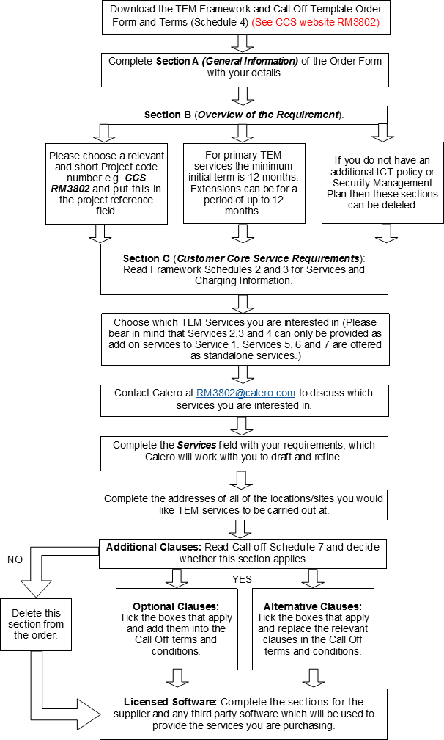

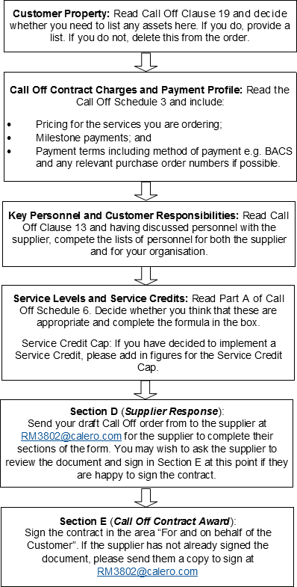
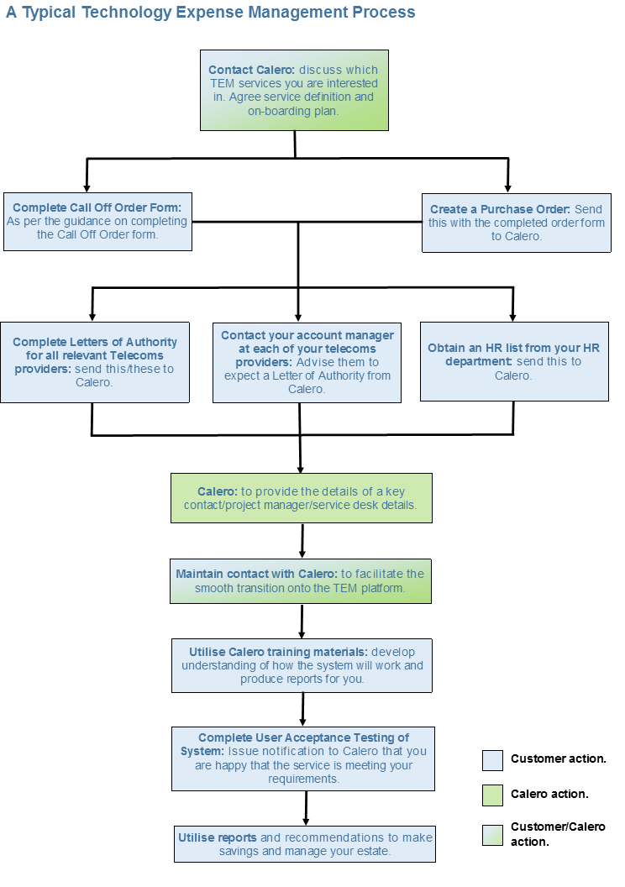
After a call off has been completed and TEM services are live:

Recording and reporting of commercial benefits:

Once you have started to realise savings through the TEM system, or have received a rebate as a result of an Historical Billing Audit, you will need to agree the benefits value with the supplier. These savings are calculated on the cashable savings you have made as a result of actions taken based on Calero’s recommendations. Once you have agreed a sum, please can you complete the template below and return it to us? CCS has a key objective to help customers realise measurable benefits from its frameworks.

Exit management:

Exit management is outlined fully within Schedule 15 of the framework. We would recommend that you read this thoroughly.

The supplier has produced a framework level Exit Plan, which conforms to the standards set out in Schedule 15. In addition, the project will have an Exit Manager, who is responsible for executing the Exit Plan as per the framework and ensuring your assets are secure.

Help and advice
If you would like help deciding which service or buying option will best meet your specific needs please get in touch with the framework commercial agreement team:

- Email info@crowncommercial.gov.uk
- Call 0345 410 2222

You can also learn more about our range of commercial deals and latest offers online:

www.gov.uk/ccs
@gov_procurement
Crown Commercial Service

