Technology Services 2 (RM3804) Delivering Social Value

What is Social Value and how does it fit into my procurement?
Driving more value through every pound spent is the main objective in all public sector procurement decisions. This includes social value benefits: social, environmental and economic considerations.
When used to full effect, service design with social value in mind can deliver a more holistic and innovative solution. In practice social value can be a cost-saving tool too, as you can deliver additional benefits through the way that a service is run without additional cost.
To get the best out of social value, it’s important to think about the potential social benefit of a service from the very start of the commissioning process. The Department for Digital Culture Media and Sport (DDCMS) have produced some useful guidance for commissioners on the Social Value Act, you can read it here.
The purpose of this short guide is to set out how social value has been considered within Technology Services 2 (TS2) at framework level to support customers in running further competitions against their own social value priorities.

At Framework Level
Social value has been considered as part of the requirement design for TS2. Both the TS2 bid pack and framework agreement has set out what the social value priorities are at framework level:
- Growth:
  - Competence: training & apprenticeships
  - Capacity: promotion of diversity, SMEs
- Transparency
  - Tax and compliance, including IR35 compliance
  - Information assurance, confidentiality and access to information
- Equality, diversity and inclusion
  - Removing / minimising disadvantages suffered by those with protected characteristics
  - Meeting their specific needs
  - Encouraging their participation in public life, or other areas where their participation is low
  - Foster good relations (tackling prejudice and promoting understanding between people who share a protected characteristic and others).
- Addressing Modern Slavery
- Environmental Sustainability
  - Energy Efficiency
  - Waste, including Waste Electrical and Electronics Equipment (WEEE), Restriction of Hazardous Substances (RoHS) and closed loop WEEE recovery
These priorities will be relevant no matter what the scale of the call-off is, but suppliers will be expected to address them in a proportionate way.

Your Further Competition
Although social value is built in at framework level we recognise that you, our customers, will have your own social value priorities. TS2 gives you the flexibility you need to set out what your priorities are and you can include these within your further competition.
Below is an extract from the TS2 framework agreement, Schedule 2. You can see here that social value requirements have been included under the quality criteria. As with all sub-criteria, the percentage weighting allocated to social value benefits can be varied provided it stays within the overall principles of the framework award criteria. Typically Local Authorities allocate between a 10% to 30% weighting to their social value considerations.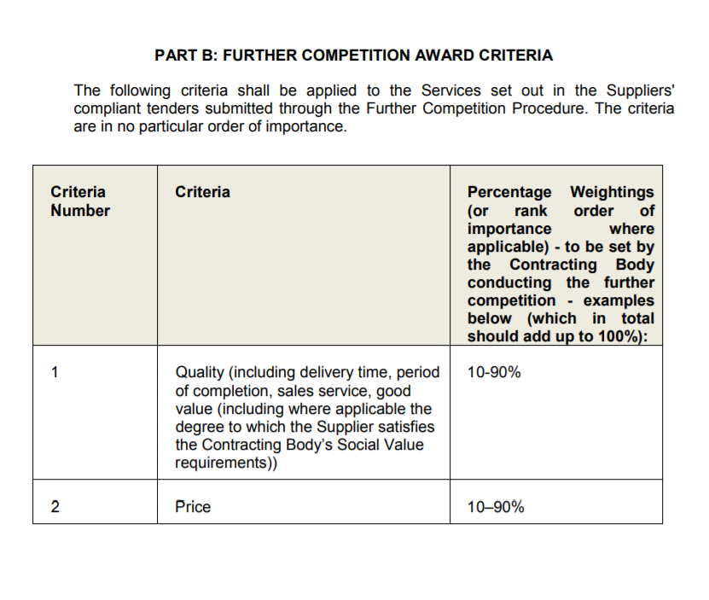
If you wish to include social value within your further competition process you must:
- Clearly set out your own social value priorities and objectives
- Set out how you will evaluate bids for the social value element. If you’re using financial proxy values, such as those developed by the Social Value portal (the National TOMS) etc, you will need to explain to suppliers how to use these.
- Ensure social value benefits offered by suppliers, or requested by you, are relevant and proportionate to the opportunity. We recommend you do this as an output based specification.
During your bid evaluation, you must treat all suppliers equally and fairly using the most economically advantageous tender (MEAT) criteria. Be sure to evaluate your bids against the same evaluation criteria you stated within your further competition documents and keep an audit trail. Remember to refer to our TS2 Buyers Guide on our TS2 website for more information on how to run a further competition.
Useful links on social value:
Social value act information and resources Crown Commercial Service social value policy Placing social value at the heart of procurement

